**AWS S3 task**

**TASK 1**

1.Creating a S3 bucket with no public access.

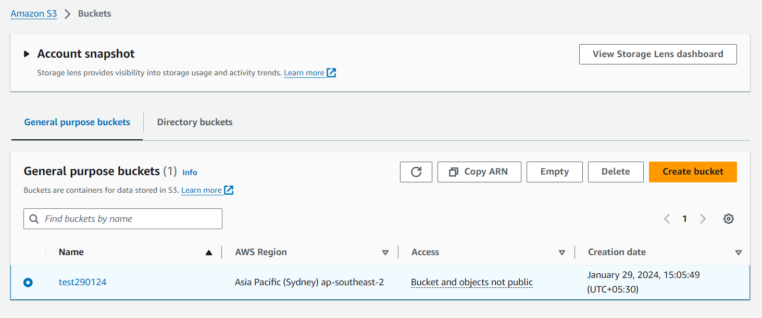

**TASK 2**

1.Creating a load balancer

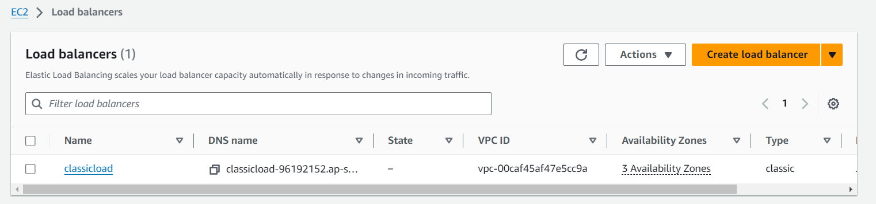

2.creating auto scaling group (AGS)

3. After attaching the load balance with the instance.

